MSSQL INSTALLATION

Step 1;

* Go to Software center Download the SQL2019-SSEI-Dev

* Click Download it will automatically downloaded

* Set the Downloaded path and Select Custom Developer Edition

* Click Install

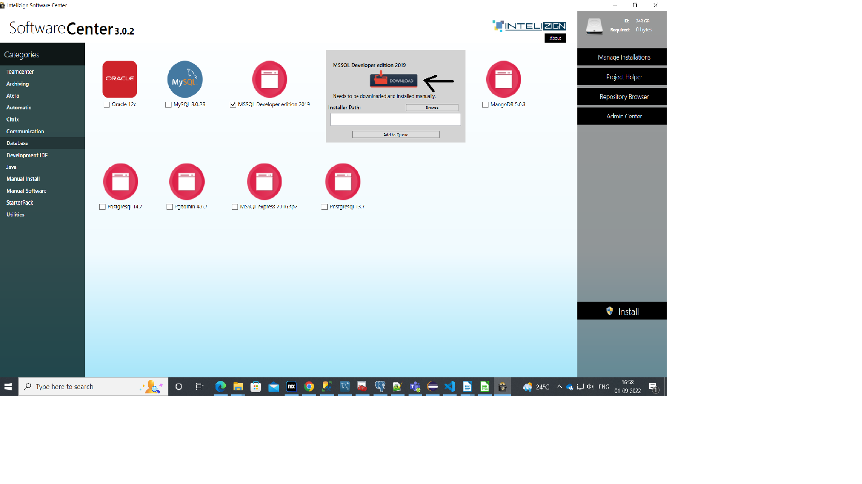

Step 2;

* Select Installation on left side navigation

* Select New SQL Server stand-alone installation

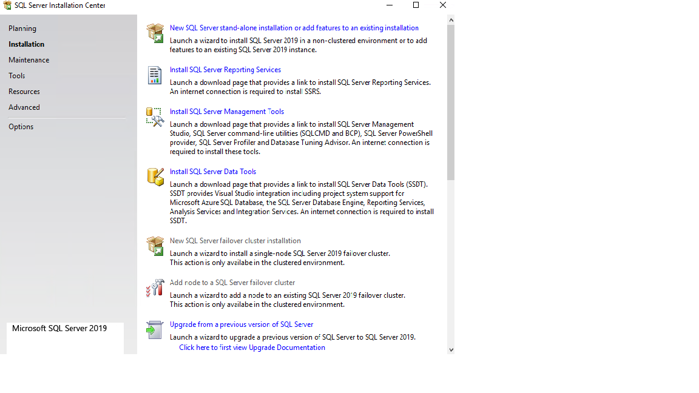

Step 3;

*Click Run

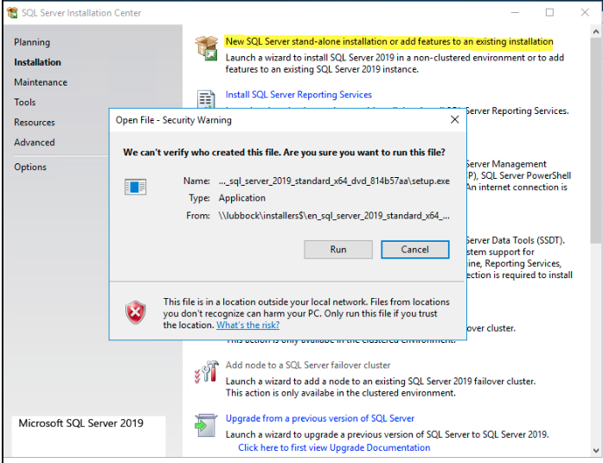

*Click next

*No need to Enter the Product Key.

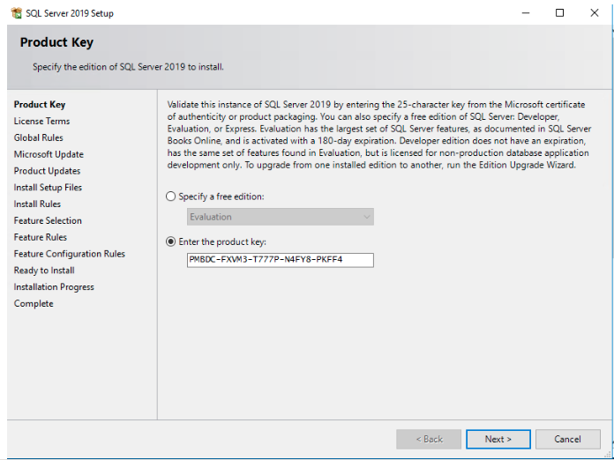

Step 4;

*Accept Licence and click next

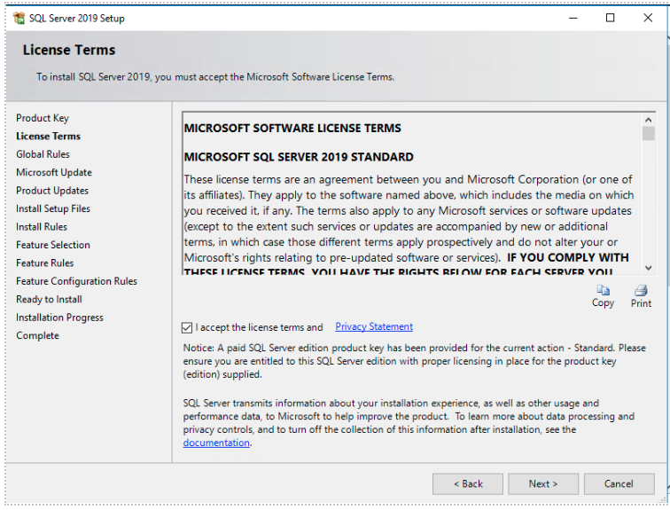

Step 5 :

* Click Next

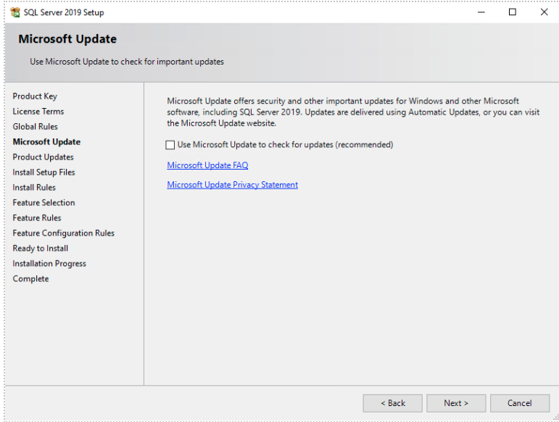

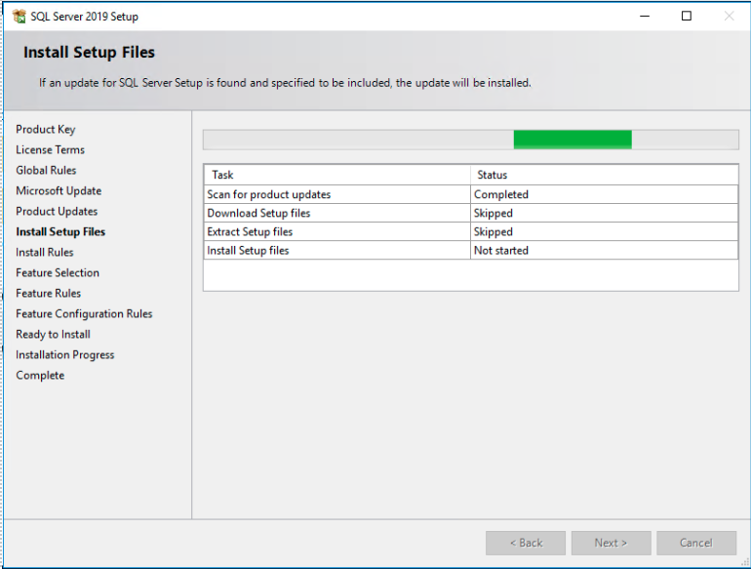

* Click Next

Step 6:

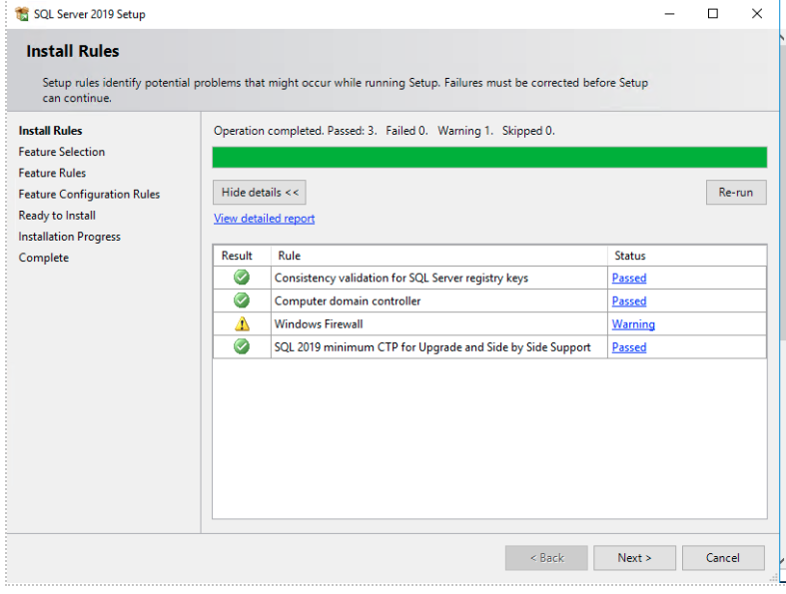

* Click Next.

Step 7 :

* Select the Features what would you need.

1. Database Engine Service

2. SQl server Repelication & Full text and semanticExtraction for search

3. SQL Client Connectivity Sdk

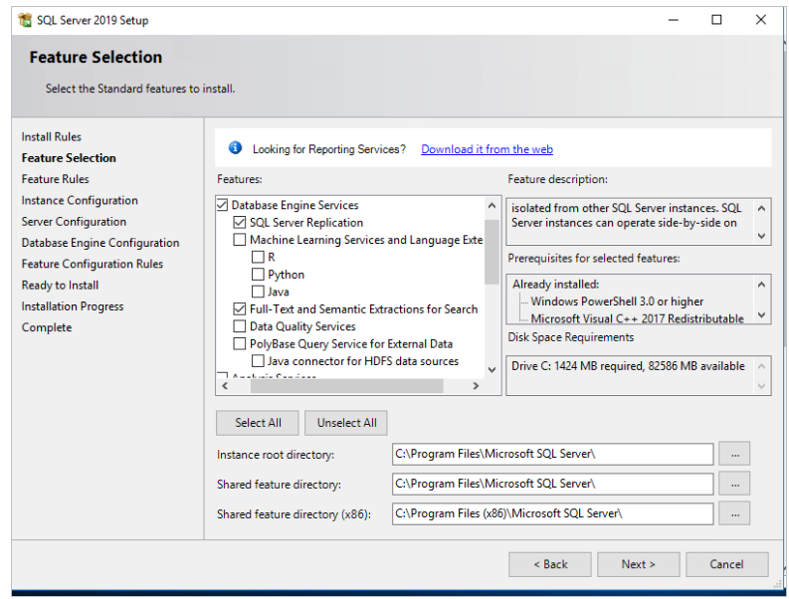

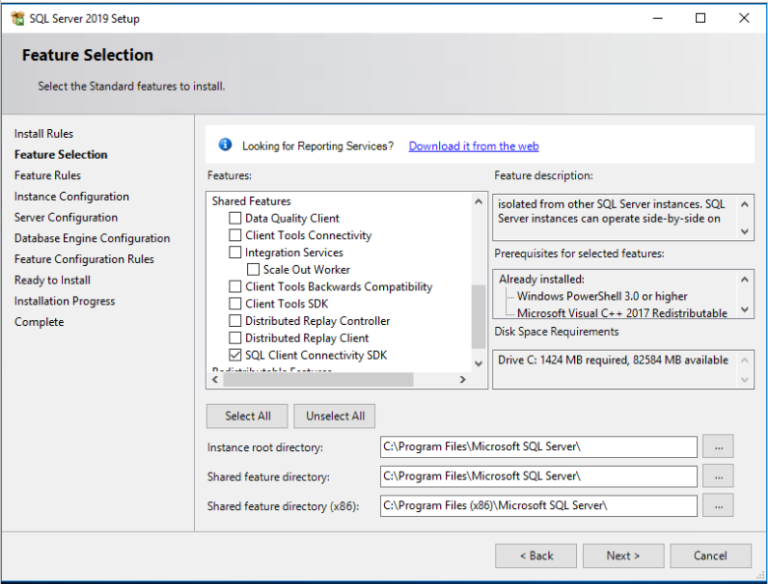

Step 8 ;

* Select Default Instance

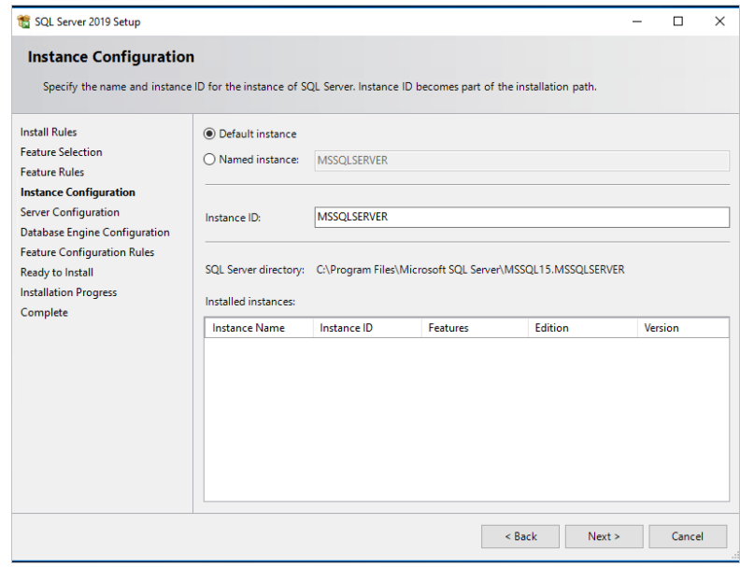

* Click next.

Step 9 ;

* Select Collation Tab

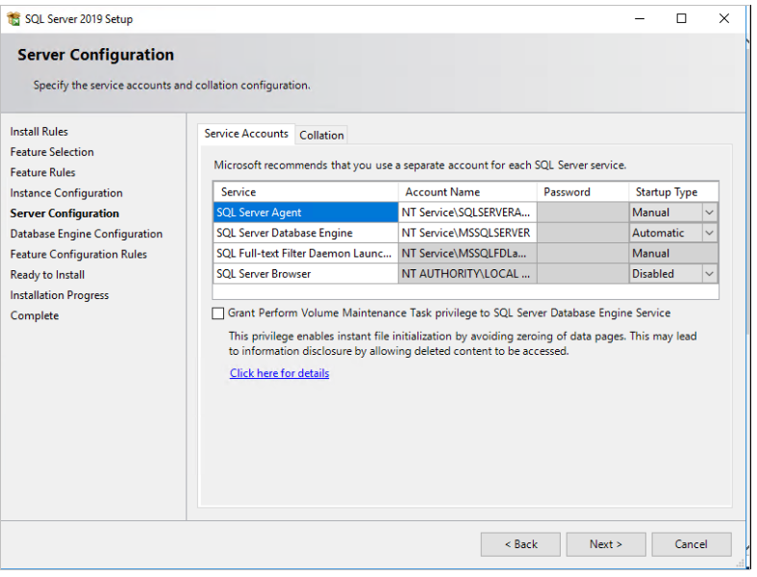

* Select Server Collate “Latin1_General_CI_AS”

* Click Next

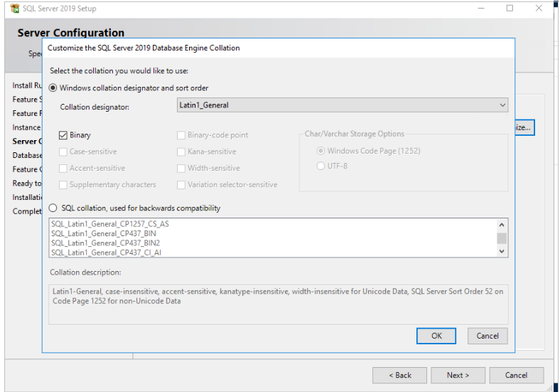

Step 10 :

* In Database Engine Configuration, Under Authentication Mode, select Mixed Mode

* Give your Password and Add current User.

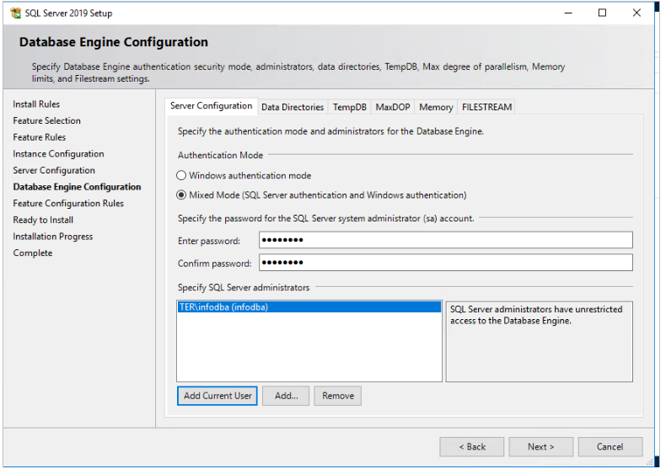

Step 11;

* Click Install.

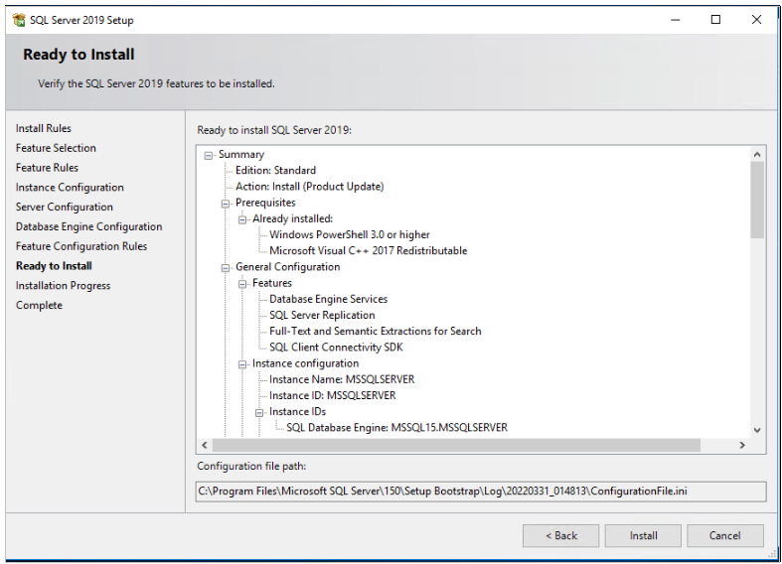

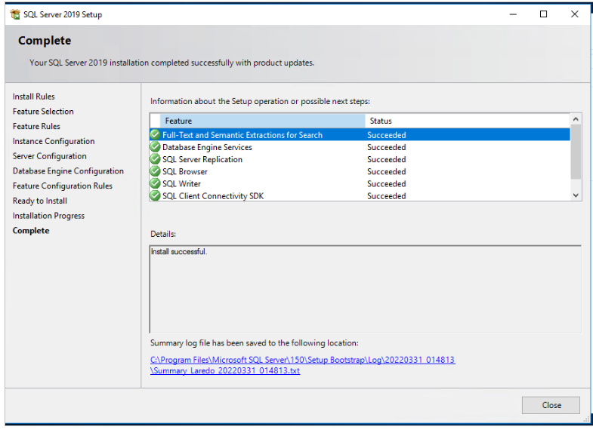

Step 12;

* Select SQL Server Management Tools

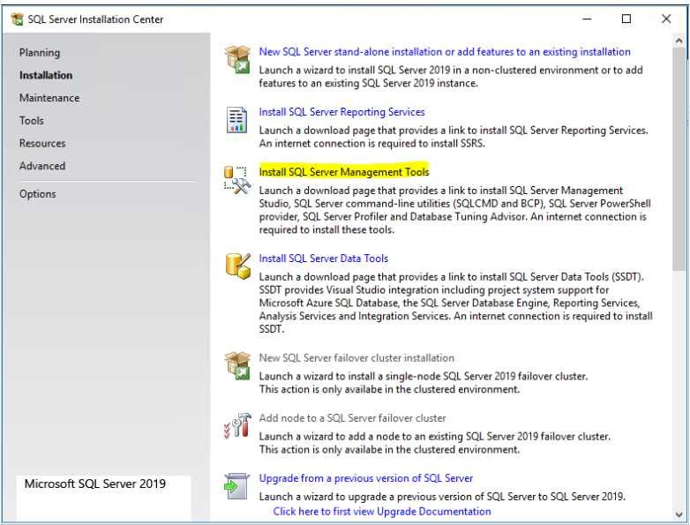

* Download setup.exe for SQL server Management Studio and RUN setup.exe

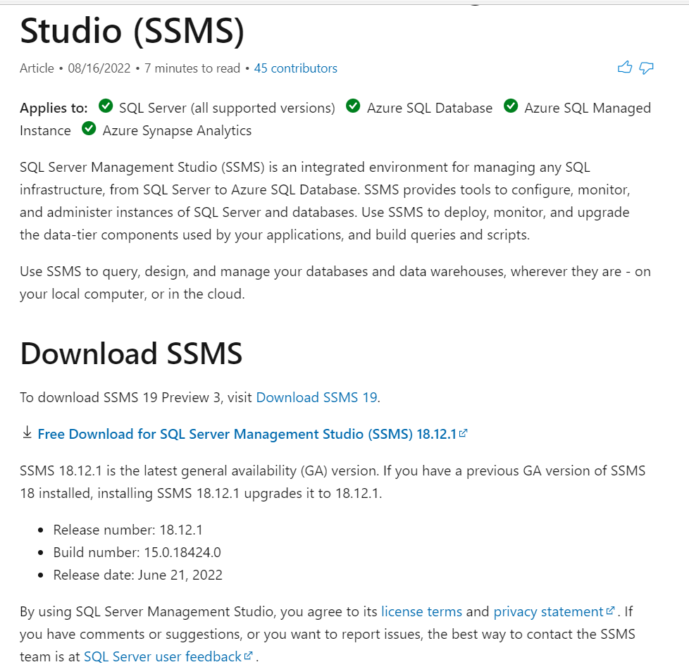

Step 13;

* Open Microsoft SQL Server management Studio

* set Installation Location and click install

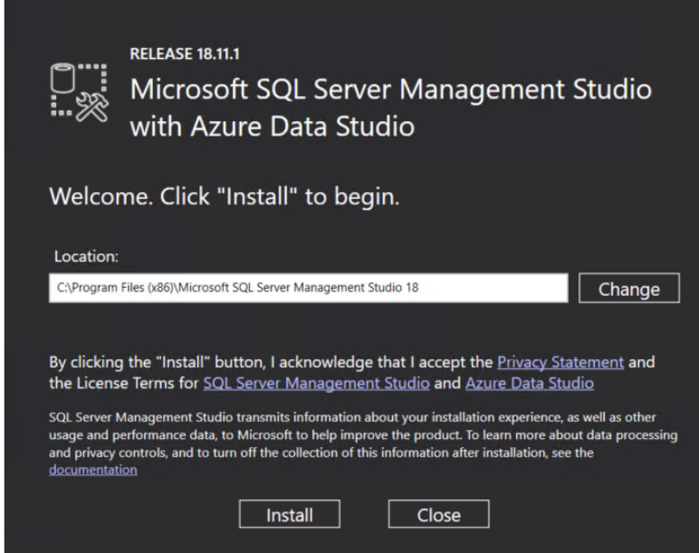

* After installation ,Do Restart.

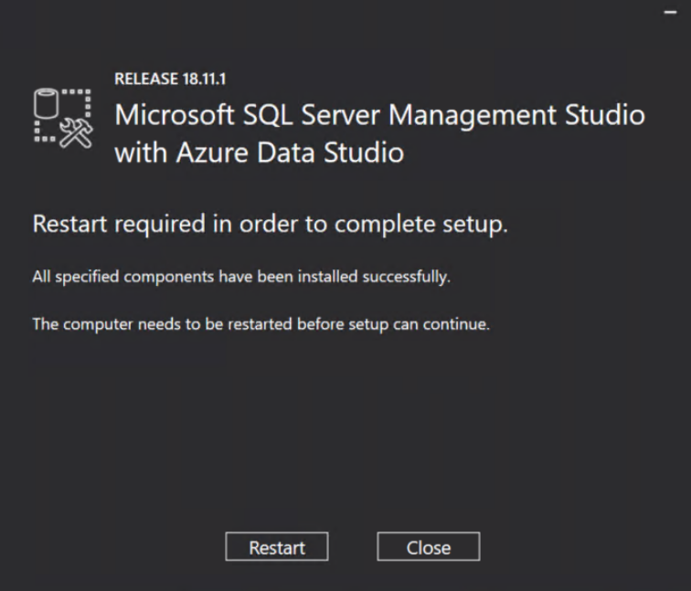

* Launch Microsoft SQL Server Management Studio:

1. search the start menu for SQL Server Management Studio

2. Select SQL Server Authentication.

3. Log on using the system administrator.

4. Username : sa.

Password: Your Password

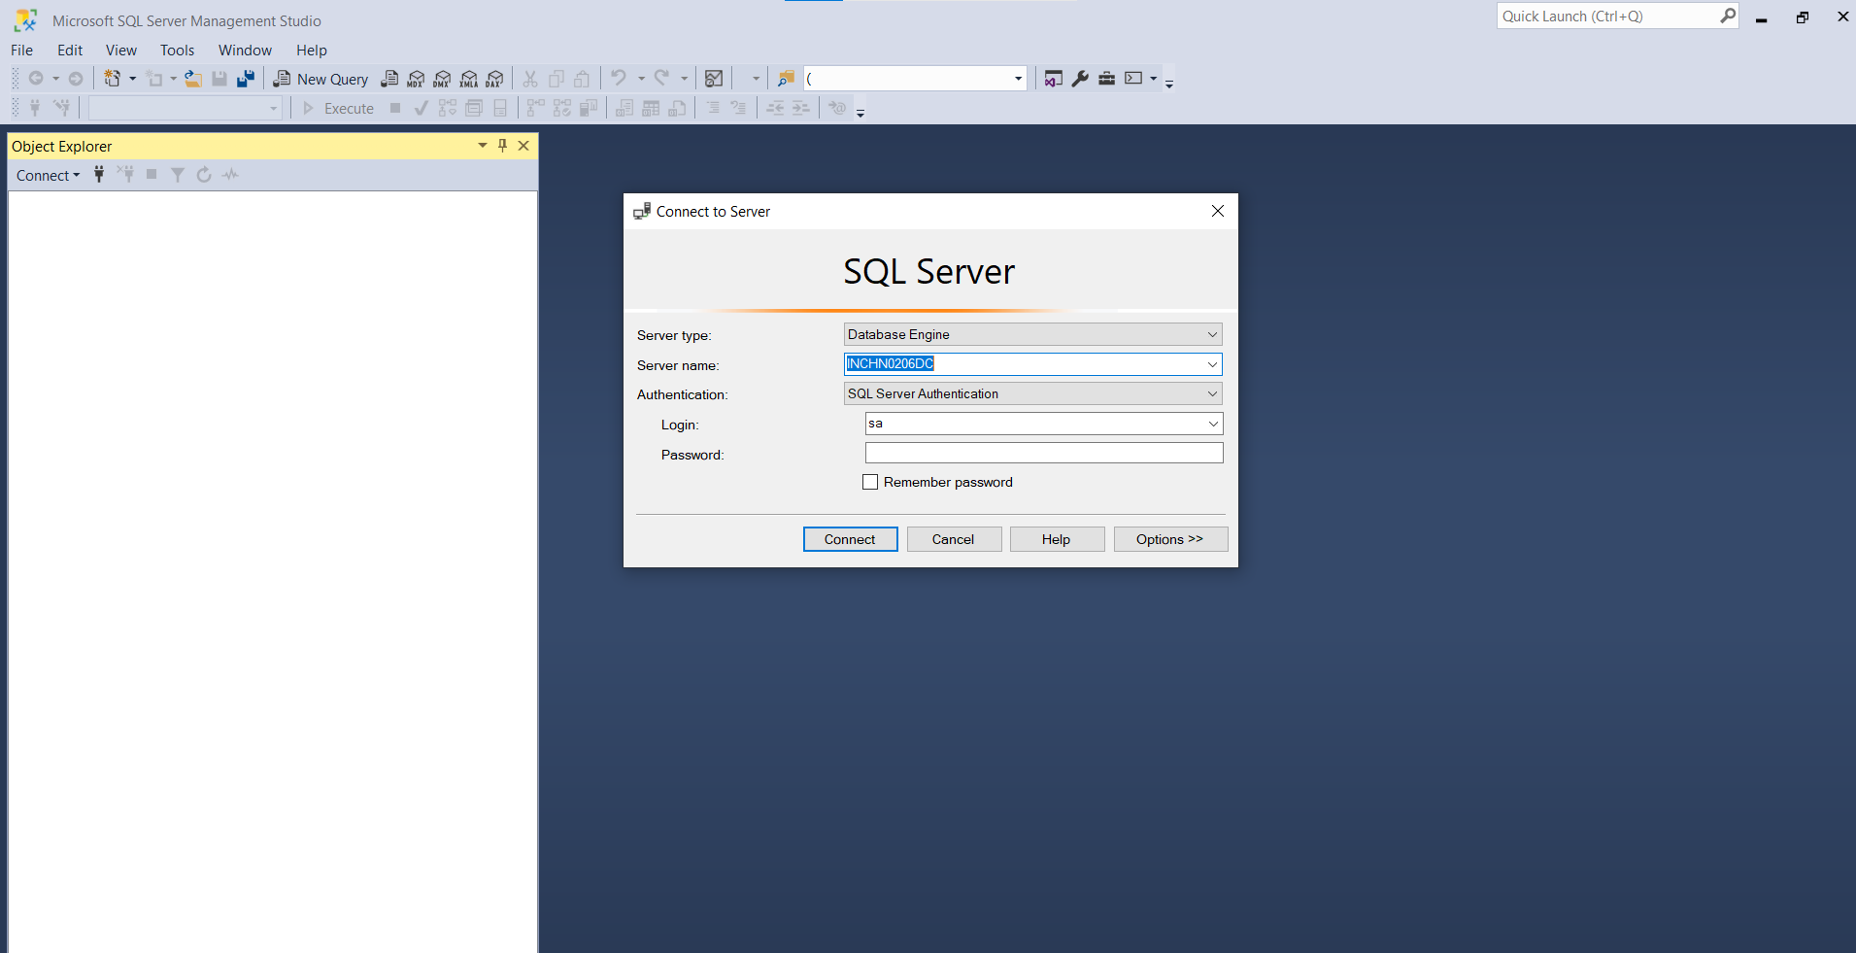

* After Completing Installation ,we have go to SQL server 2019 configuration manager
* keep the TCP/IP, named pipes as enabled
* Verify the port 1433 in TCP/IP by clicking its properties

